Virtualization Software: is a software that allows a Physical Machine to create Virtual Machines.
Hypervisor: A Hypervisor is a Virtualization Software.
There are two types of Hypervisor.
1) Hypervisor 1: You buy a BareMetal, and you want to create more machines out of that BareMetal, you install the Virtualization software

On the BareMetal, first then you will be able to create more Virtual Machines. Some of the most preferred Virtualization Software in IT Industry is VMWare, Red Hat KVM [ KERNEL BASED VIRTUAL MACHINE] & Hyper-V.

2) Hypervisor 2: Hypervisor 2 has an Operating system already installed. It will facilitate the Virtualization software on the existing Operating System. For instance, existing Operating system in this case is our Windows Operating System.

Some of the most preferred Virtualization software used on Laptops/Computers/Desktops are ORACLE VIRTUAL BOX & VMWARE WORKSTATION.
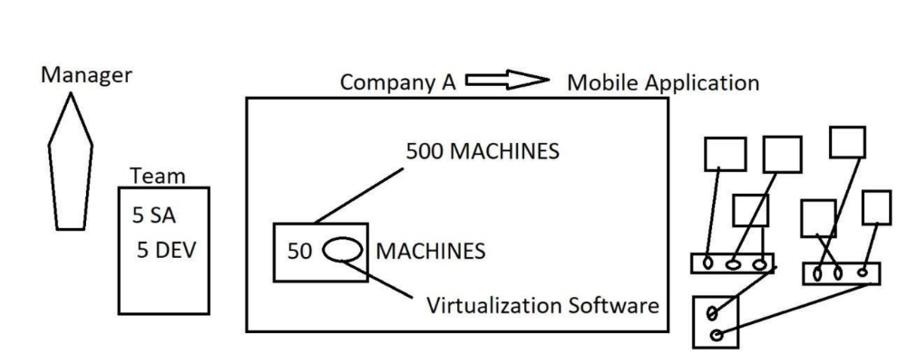

Capacity Pool: allows the Resources to be allocated to Virtual Machines Dynamically based on the needs. We can create more Virtual Machines based on the availability of Resources available in Capacity Pool (Physical Machine).
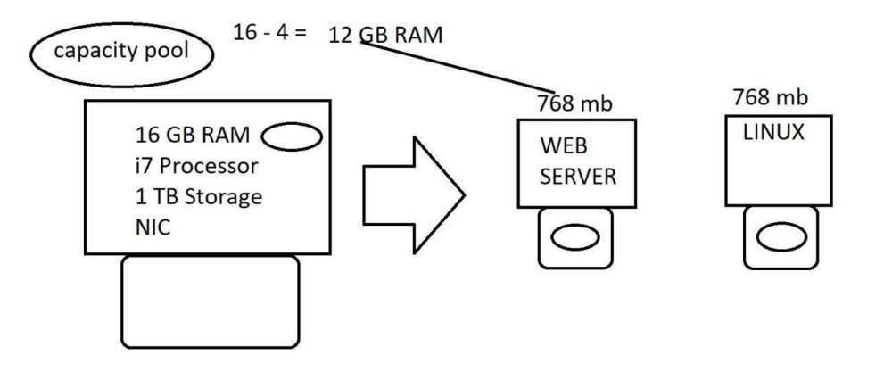
UNIX/Linux COMMAND & CHEAT SHEET:

In UNIX/Linux, the default shell is bash [ Bourne again shell]
• Command to check the default Unix shell. echo $SHELL

/bin/bash
Different prompts on the Shell.
# - prompt for root shell
$ - prompt for a normal user shell

Note: In UNIX/Linux EVERYTHING STARTS WITH / (THIS FORWARD SLASH IS REFERRED TO AS ROOT)
Command to print the hostname. hostname
Command to change the name of the machine (temporary)
hostname <whatever name you want to set>

command to print date and time. date
command to print the current user session. whoami
command to create a directory.
mkdir <name of the directory>
include verbosity on the command line to get the info.
mkdir -v <test>

command to check the contents of a directory. ls
command to create parent directories. mkdir -p a1/b1/c1

In UNIX/Linux, we always use a Forward slash (/) whereas in Windows we use a backslash (\).
• command to access a specific directory.

cd <name of the directory> where cd stands for change directory.

Command to check the current location in the Server/session/UNIX shell.
pwd
where pwd stands for print working directory

Note: For a Root user, the default home directory is always /root
Command to switch to a Parent directory --> cd ..

Command to be in a current directory --> cd .

where single dot refers to the current directory & double dot refers to the parent directory

For example:
/root/a1/b1/c1/d1/e1/f1
cd ..

command to create a hidden directory.

mkdir .magic

command to clear the screen on a shell -> clear

#######################################
Let’s learn how to create Files....
###########################################
command to create an empty file -> touch <name of the file>

command to remove the alias for a particular highlighted entry.

unalias ls

Apply extension to the ls command.

ls -l --> long listing.
ls -la --- > To list all hidden files & directories.
Directory starts with d
Regular file starts with –

Command to create a file with some content.
vi <filename>

once you are done adding the content, hit esc then :wq! from your keyboard.

Command to view the content of the file.
cat <name of the file>

To add something to an existing file without losing the original content use append
append (>>)

To get the exact count of words, lines or characters use wordcount.
wordcount is represented by wc.
wc -l <name of the file>
wc -w <name of the file>
wc -c <name of the file>

Scenario: Interview Question:
Create a file with some content and redirect it to another file
[Do not use Redirect > option though]

cat <name of the existing file> | tee <name of the new file>

Command to create a hidden file.

touch .machine
Definition of a pipe is to evaluate a condition.

Paths in UNIX
- Absolute Path
- Relative Path

- Absolute Path : An absolute path always starts with a root (/). This path identifies all the directories and subdirectories.
For instance: /a1/b1/c1/d1/e1/f1 is referred to as an absolute path since the path is starting from root (/)
- Relative Path : A relative path never starts with a root (/) . It starts with the following.

* Single dot
* Double dot
* ls

For instance: Full Path is /a1/b1/c1/d1/e1/f1
pwd
/a1/b1/c1/d1/e1

I am in e1 ---> Task is go to f1 but do not use a single dot,a name

just use a double dot to go to f1

cd ../e1/f1

#################################################################

/sample/test/oracle/sql/11.2.0.3/ora.ini
pwd
/sample/test

cd ./oracle/sql/11.2.0.3
pwd

/sample/test/oracle/sql/11.2.0.3

ls ora.ini
cat ora.ini

pwd
/sample/test/oracle/sql/11.2.0.3

cd ../../../..
pwd

/sample
################################################################

##################################################################
How to Copy files and directories from source to destination
Syntax to copy a file --> cp -p <source> <destination>
Syntax to copy a directory --> cp -rp <source> <destination>

where source and destination can either be an absolute path or relative path
-p refers to permissions
-r rerers to recursive

Consider we have two locations
/root/a1/b1/c1/d1/e1/f1 --> location 1
/root/sample/test/oracle/11.2.0.3 ---> location 2

First let's create a file called file1.log in /root/a1/b1/c1/d1/e1/f1

copy the file, file1.log from /root/a1/b1/c1/d1/e1/f1 to /root/sample/test/oracle/11.2.0.3

cd /root/a1/b1/c1/d1/e1/f1 touch file1.log
cp -p /root/a1/b1/c1/d1/e1/f1/file1.log /root/sample/test/oracle/11.2.0.3
cd /root/sample/test/oracle/11.2.0.3
ls -ltr
#####################################################################
Move Concept ---> Both Source and destination should exist.
Syntax for move --> mv <source> <destination> ---> applies to both files and directories
where source and destination can either be an absolute path or a relative path.

######################################################################

Rename concept ---> old name exists and new name doesn't
syntax for rename ---> mv <old name> <new name>
where old name can either be a file name or a directory name

#######################################################################

Remove the file and directory
Syntax for removing a file ---> rm <path of the file>
Syntax to remove an empty directory ---> rmdir <path of the directory/name of the directory>
Syntax to remove a directory with content ---> rm -rf <path of the directory/name of the directory>

#######################################################################
Permissions:

Every file/directory will have an ownership.

The ownership containts User/Owner & Group info ONLY

Let's take a look at the default permissions of a file & a directory
-rw-r--r ------> Permissions for a file
drwxr-xr-x ----> Permissions for a directory

In general,
r stands for read w stands for write
x stands for execute
Permissions are of two types.
1) Symbolic Permission
rwx
when we deal with permissions there are 3 categories to be considered
1) User/owner Category [ U ]
2) Group Category [ G ]
3) Others category [ O ]

U G O
- rw- r-- r--
U G O
d rwx r-x r-x

What is the way to assign a permission to a specific category using symbolic method

chmod u+/- <name of the file/directory>
chmod g+/- <name of the file/directory>
chmod o+/- <name of the file/directory>
chmod a+/- <name of the file/directory>

2) Octal permission
r = 4
w = 2
x = 1
-rwxr-xr-x file1
755
655 ===> rw-r-xr-x
700 ===> rwx------
701 ----> rwx ---- x
644 ----> rw-r--r—

Syntax for Octal format --- > chmod 755 <file/directory>

###############################################################################
What is UMASK ---- > umask is a default numerical value that will assign permissions for a file/
directory.
For root user, a default file and directory permissions are as follows
file - 644
directory – 755

For a normal user, a default file and directory permissions are as follows
file - 664
directory – 775

what is the command to check the umask value?
command is umask

umask value for a root user is 0022

umask value for a directory is 777 umask value for a file is 666

777 | 666
022 | 022
755 | 644

umask value for a normal user is 0002

umask value for a directory is 777 umask value for a file is 666

777 | 666
002 | 002
775 | 664

Default UNIX/LINUX SHELL IS BASH
echo $SHELL

UMASK Value is defined in the Users global configuration file which is /etc/bashrc

The condition evaluated in /etc/bashrc is

if uid -gt 199 && [ id -un command should match the command output for id -gn]
umask = 002

if it doesn't meet the condition then
umask = 022

uid for root is 0
uid for normal users starts with 1000 > 1000

& is referred to as ampersand.

Why do we need to study Links in Unix/Linux?
Links is the best way to preserve the data in multiple locations without the need of copying the data from one location to another. A linked file will reflect the newly added data in duplicate file locations accordingly.
Copy ---> it takes a backup of the original content in a duplicate location.
/root File1
mango apple banana

/root/sample File2
mango apple banana
Links: Link is a pointer to the original location. There are two types of Links in Unix/Linux.

1) Hard link - It applies only to files. The hard links doesn't work on directories.
Link count --- > is a special count generated when a file or directory gets created. For a regular file, the link count will always be 1. For a directory, the link count will always be 2.

The link count gets changed from 1 to 2 for a regular file if that file is having a hard link.....
Syntax to create a Hard link ----- > ln <source> <destination>

where source and destination can either be an absolute path or a relative path.

INODE --- > A META DATA OF A file which has certain details as to when it was created, who created,

what is the byte size and it also reflects an inode number
To validate all the hard link files and their locations using inode number, use find command What is

the command to check the inode number of a file
ls -i <filename>

##################################
Conclusion with Hard Links:
##################################
* A hard link file will have a link count starting with 2 and it keeps on increasing based on the number of links
* A hard link is applicable only to files and NOT Directories
* The inode number of a hard link file is always the same
* In order to find all the locations of a hard link file, use the inode number followed by the find command

for instance:
ls -i <filename> ---> prints the below output inodeno filename

Capture the inodeno and use the find command as shown below.
find / -inum <inodenumber> ---> prints all the locations of the linked file

In hard links, if you delete the duplicate file, no impact to the original file likewise if the original file is
deleted then no impact to the duplicate file

In symbolic/soft link, when you delete the duplicate files/Directories, no impact to the original files/directories but if the original files/directories are deleted then FULL impact to the duplicate files/directories.

2) Symbolic/soft link
Syntax: ln -s <source> <destination>
where source and destination have to be absolute path. Symbolic/soft link applies to both files and directories.
################################
Conclusion with Symbolic/Soft links
################################
Inode number in symbolic/soft link will be different for files and directories.

In Symbolic/softlink, no matter how many links are created for a file/directory all the files and directories will have a link count of 1
In symbolic/soft link, when you delete the duplicate files/Directories, no impact to the original files/directories but if the original files/directories
are deleted then FULL impact to the duplicate files/directories.

In UNIX/Linux, if you want to change the root password then execute the below command.
passwd

It will prompt to enter the password. This password is not visible so please ensure you type the password carefully

To validate all the Users present in the system, we can refer to the Users configuration file which is /etc/passwd

To validate all the Users group info, refer to /etc/group

To validate if a User has a password set up or not, refer /etc/shadow file and the password
for a user should be in encrypted form if the password is set or else the password will be empty.

Command to switch to a regular user from root user.
su - <name of the regular user>

#which passwd
/bin/passwd

ls -l /bin/passwd
-rwsr-xr-x ........

########################
setuser id
########################
Setuser id is applicable only to system related files.
set user id is a special privilege given to a system related file to allow not only root user
to execute the commands but also regular users can execute the same commands even though they do not have the ownership.
setuser id has an octal value = 4

Assign Set user permissions using Symbolic method:
chmod u+s <name of the file>

Octal method: chmod 4755

Remove Set user permissions using Symbolic method:
chmod u-s <name of the file>
Octal method:
chmod xxx <name of the file>

setuserid does not apply to directories.

########################
setgroup id
########################
set group id will have an octal value = 2

Assign Set group permissions using Symbolic method:
# chmod g+s <name of the directory>

Octal method:
# chmod 2xxx <name of the directory>

Remove Set group permissions using Symbolic method:
# chmod g-s <name of the directory>

Octal method:
# chmod 00xxx <name of the directory>

set group id will be applicable to directories. command to create a new group in UNIX. groupadd <name of the group>

Create a directory and apply group ownership using below command.
# chgrp <name of the group> <name of the directory>

To add existing Users to an existing group, use the below command.
# usermod -a -G <existing group> <existing User>

Now regular Users creating files and directories in setgroup directory will always have the group ownership same as the setgroup directory group ownership.

#########################
sticky bit
#########################
Sticky bit is applied on both Files and Directories.
Sticky bit permission ensures that other users cannot delete the files and directories in a Parent directory whose permissions are accessible to all.
Sticky bit owned Files and Directories can be deleted only by the root User or the owner of the file/directory.
Sticky bit has an octal value of 1. By default, /tmp directory will have sticky bit assigned.

Assign Sticky bit permissions using Symbolic method:
chmod u+t <name of the file/directory>

Octal method:
chmod 1xxx <name of the file/directory>

Remove sticky bit permissions using Symbolic method:
# chmod u-t <name of the file/directory>

Octal method:
# chmod 00xxx <name of the file/directory>

Process Management:
Unix Shell - is an interpreter that translates the information between Unix Kernel and the User and vice versa.
Command to check how long the Server has been up.
# uptime
In UNIX, we have a default manual which has a history of all the Unix commands and their extensions.

Command to execute a history on Unix commands.
man <ls> --> for example!
Program: A program could be any command, or an executable script run to perform a specific task. Process: Process is nothing but a program that is executed in memory.
Every process will have a unique process ID (PID).
Process Management: There are two types of processes in Unix.

1) Foreground process
Any process that is executed on the Unix shell completes the task and returns the output is a foreground process.

2) Background process
A background process is used in case scenarios where a program takes a lot of time or a specified time to complete a task. such tasks are not executed in foreground mode. They are meant to be run in Background mode.
To run any program in a background mode, enter ampersand at the end of the program.
sleep 120 &
[1] 1267
where number 1 in the bracket points to the Job ID and the number beside the Job ID refers to the process ID

Command to print all the processes running on the Server.
# ps -ef --> will print all the processes running on the Server

where e stands for every process and f stands for full long listing
If you want to analyze the output of ps -ef such that it fits in your screen, use the Pipe condition followed by more.
ps -ef | more
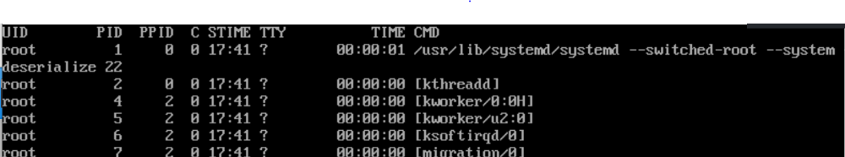

Where UID stands for User ID who started the process, PID stands for Process ID, PPID stands for Parent Process ID, C stands for CPU utilization count in percentage, STIME refers to the time when the process was started, TTY is the terminal where the process was initiated from, Time refers to how much time has elapsed since the process has started & CMD is the command/arguments run.

Use case scenarios for Background process:
1) A background process can be run in foreground mode is fg % [job number]

where fg stands for foreground mode

2) Can a background mode job be suspended ---> No, a background job cannot be suspended. It can only be killed or terminated.

However, a foreground mode job can be suspended, and the suspended job can either be started in foreground mode or background mode.
To start a suspended process in background mode, use the below command.
bg % [job number]
where bg stands for background mode

Killing a Process:
There are two ways you can kill a background process.
kill % [job number]
ps -ef | grep <process name>

you will get a process ID and a Parent process ID.
If someone ask you how to find out the process ID of a background job ps -ef | grep <process name>
this will print the process ID.

kill <process ID> ---> this will kill the process.
kill -9 <process ID> ---> the number -9 refers to SIGKILL, this number is used when you want the OS to kill a program instantaneously. The number -15 refers to SIGTERM where it cleans up the program in a graceful manner. Though both number 9 & 15 are used to terminate a process but when number 9 is used it is guaranteed to kill a process quickly when compared to number 15.

IP Address:
Our HOME WIFI Uses DHCP IP ---> DHCP (Dynamic Host Configuration Protocol) ---> The role of DHCP is to broadcast the info.
The gist of the topic is that a DHCP IP will be used to communicate to Internet whereas a static IP is more suitable for a local network.
What makes up an IP Address --> A combination of Host ID & Network ID will make up an IP Address. IP Address range used in our case is 192.168.56.x
Every Server/Machine/Node will have a Unique IP Address

How to set up a hostname temporary way and Permanent way:
hostname <name of the server> ---> temporary way ---> this setting will be lost when the server is rebooted.
hostnamectl set-hostname <name of the server> ---> Permanent way ---> Setting will be persistent across a reboot.

VI EDITOR:
Syntax for a vi editor
vi <filename> ---> will open and create a file and it will prompt you to enter the data. There are 3 modes in a Vi editor.
- Command mode
- Insert mode
- Execute mode vi sample

Once the file is opened, you will be in command mode and you have to press ESC from your keyboard just once and use below alphabets to play around the file.
j --> go down. k --> go up.
l --> go right. h --> go left.
shift $ will take you to the end of the line. 0 will take you to the beginning of the line.
shift a will allow you to add something at the end of the line. yy --> will copy the entire line.
p ---> will paste the content below the cursor.
shift p --> will paste the copied content one line above the cursor.

cw ---> change a word. take the cursor to the beginning of the word and do cw to change the word. r --> for replace. press l, go to right and press r first then replace the alphabet of your own interest. x --> to delete a word alphabet by alphabet.
:set nu (hit enter) --> to enable line numbering in a vi editor file.
gg --> to move from the bottom of the file to the beginning of the file. shift d ---> will delete the word.
shift g --> go from beginning of the file to the end of the file.
: %s/existing word/new word/g [hit enter] -→ will replace the existing word with a new word.
: number ---> will take you to that line. dd ---> will delete the line.
shift u --> it will start the roll back changes and these changes will be rollback if the vi editor file is not saved.
:%y --> will copy all the contents in a file and if you want to paste it press p in the same file.
:e path of the file ---> after copying the file content using :%y from file1 you can use :e /root/file2 to paste the contents of file1 in file2 ...use shift p and remove any empty lines at the end using dd command
ESC i
To save and quit a file in vi editor you type ESC :wq! If you just want to quit the file , do :q!

##################################################################
SET UP NETWORKING:
command to check the network interfaces on the Linux OS.

ifconfig -a [ This command requires net-tools package to be installed. Install it using yum install -y net- tools command]

default inbuilt command to check network interfaces is ip addr

Configuration file for network interfaces will be stored in /etc/sysconfig/network-scripts (For RHEL 7 & 8 Versions)

SET UP KEYBASED (PASSWORDLESS) AUTHENTICATION BETWEEN TWO SERVERS for a Data Migration Project:
We always use a service account (amin) to set up key based authentication between servers.
Once key based authentication is set up, use UNIX migration tools to copy the data from One server to another server.

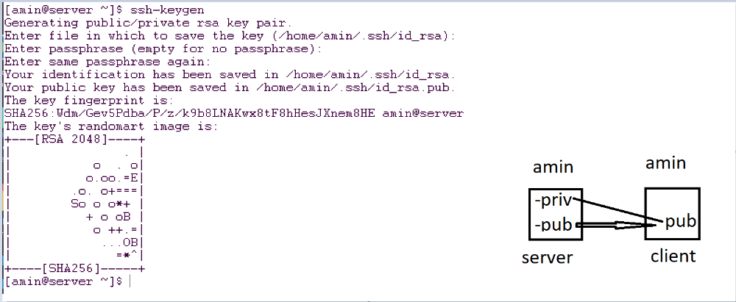

systemctl restart network
systemctl enable network
validate if the IP Address is reflecting on the nic or not
ip addr
Connect to the machines using GIT BASH use ssh --> Default port for ssh is 22
ssh root@<IP ADDRESS> from GIT BASH to connect to the machine...
SET UP KEYBASED (PASSWORDLESS) AUTHENTICATION BETWEEN TWO SERVERS for a Data Migration
Project:
• we always use a service account (amin) to set up key based authentication between servers.
• Once key based authentication is set up, use UNIX migration tools to copy the data from One server to another server.

To copy public key from one server to another server, use the below command
$ ssh-copy-id -i id_rsa.pub amin@destinationserver
Enter password only once and it should create .ssh/authorized_keys in amin’s home directory on destination Server.
# mkdir /sample && chown amin:amin /sample && su – amin
$ cd /sample
$ touch file{1..100} && mkdir sample{1..50}
# mkdir /project [ Client Server]
# chown amin:amin /project
# su – amin

COMPRESSION METHODS [TAR, GZIP & ZIP]:
• Create a TAR (Compressed) file of all files and directories.

$ tar cvfz test.tar.gz * → all files and directories will be compressed.
Where c stands for create, V stands for verbosity, F stands for force & Z stands for compress.
• To view the contents of the tar file

$ tar tvfz test.tar.gz
• To extract the contents of the tar file

$ tar xvfz test.tar.gz
• To compress a single file, use gzip

$ gzip <name of the file>
After the file is gzipped, the file will have an extension of .gz. To view the contents of a .gz file use zcat <file1.gz> command.
• To uncompress a gzipped file, use gunzip

$ gunzip file1.gz
• To use zip and unzip commands, Install zip and unzip packages using yum as root # yum install -y zip unzip

$ zip -r Final.zip <name of the files>
$ unzip Final.zip
• To Transfer a regular file, a TAR file, GZIP file & ZIP file use Secure COPY command

• Syntax for SCP:

$ scp <name of the file> <name of the user>@<name of the server>:<dest location on the server>
➔ For example: scp test.tar.gz amin@client:/project

To remove the file content in Unix but do not delete the file itself run the below command.
# cat /dev/null > file.txt
where /dev/null acts as a null pointer which does the cleanup operation.

Command to check if a package is installed or not.
# rpm -q <name of the package>
ls -lt command will show the latest files and directories at the top output.

Rsync - a fast, versatile, remote (and local) file-copying tool used to copy both files and directories.
Syntax for rsync is rsync -azvh source amin@destinationserver:destlocation
where a is for archive
z is for compress
v is for verbosity
h is for hashing ( ###################### )

SFTP (secure file transfer protocol) is used only for files.
To upload a single file from source server to the destination server.
sftp username@destserver
>put <filename>
>!ls [ not ls will show the contents of the source server & ls will show the contents of the dest server ]
>bye (it will exit from sftp)

To upload multiple files from source server to the destination server.
sftp username@destserver
>mput <filenames> [ Use a wild card * ]
>!ls [ not ls will show the contents of the source server & ls will show the contents of the dest server ]
>bye

To download a single file from destination server to the source server.
sftp username@destserver
>get <filename>
>!ls [ not ls will show the contents of the source server & ls will show the contents of the dest server ]
>bye

To download multiple files from destination server to the source server.
sftp username@destserver
>mget <filenames> [ Use a wild card * ]
>!ls [ not ls will show the contents of the source server & ls will show the contents of the dest server ]
>bye

AWK & CUT Commands [used to print columns]
awk -F ":" '{print $1,$7}' /etc/passwd --> will print the first and seventh columns from /etc/passwd file
ls -l | cut -d " " -f1,2 --> will print the first and second columns of ls -l output.

GREP Command [Used to grep a particular pattern from a file]
grep "string" <name of the file>
grep -i "string" <name of the file> [if you want to avoid the case sensitivity, use the interactive option i] grep -v "string" --> will ignore the string in the output.
grep -R “LINUX” /root [will search all the files and directories in /root for the word LINUX]

Wild Card Commands [A shortcut to retrieve files with a pattern]
# touch file{1000..1005} # ls
file1000 file1001 file1002 file 1003 file1004 file1005
# ls file????
file1000 file1001 file1002 file 1003 file1004 file1005
# ls File.zip File.zip
# ls *.zip File.zip
# ls file??
file10 file11 file12
# ls file.tar.gz file.tar.gz
# ls *tar* file.tar.gz

SORT & UNIQ COMMANDS
# cat num.txt 5
3
4
# cat num.txt | sort -n 3
4
5
# cat essentials.txt
grapes
grapes
mango
mango
#cat essentials.txt | uniq
grapes mango

FIND COMMANDS [Are used to find files and directories, Ownership, Permissions]
find /root -name sample [ Will find sample name in /root ]
find /root -name sample -exec ls -l {} \; [ will list the contents of sample ]
find /root -user amin -exec ls -l {} \; [ will list the files and directories owned by amin user]
find /root -group tom -exec ls -l {} \; [ will list the files and directories owned by tom group ]
find /root -type f -mtime +2 [ will list the files created in /root two days ago ]
find /root -type d -mtime +5 [ will list the directories created in /root 5 days ago ]
find /root -name sample1 -exec chown root:root {} \; [ will change the ownership of sample1 in /root to user root & group root ]
find /root/sample1 -name test -exec chmod 777 {} \; [ will change the permission of test file in
/root/sample1 to 777 ]

SED [Stream Editor] ---> will change the value in the output only but the original content remains the same.
# cat fruits.txt mango grapes
# sed 's/mango/orange/g' fruits.txt
orange
grapes

